Worksheet 5 Graphs

Task 1
1. (a) Create an adjacency matrix to represent the following graph:

 | E | T | G | M | F | H | S | P
E |  |  |  | 7
T |  |  |  | 5 | 9
G |  |  |  |  | 4 |  |  | 12
M |  |  |  |  |  | 2 | 3 | 14
F |  |  |  |  |  |  | 2
H
S
P

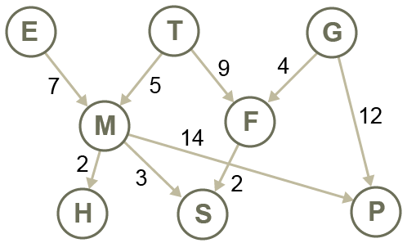

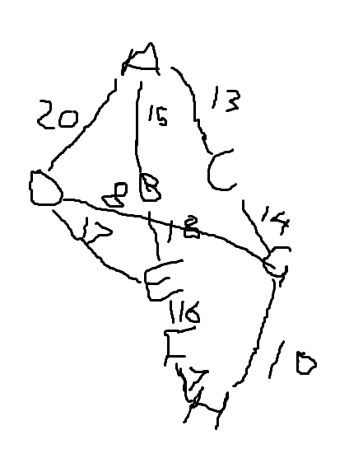
(b) Draw the graph represented by the following matrix:

 | A | B | C | D | E | F | G | H
A |  | 15 | 13 | 20
B | 15 |  |  |  | 18
C | 13 |  |  |  |  |  | 14
D | 20 |  |  |  | 17 |  | 8
E |  | 18 |  | 17 |  | 16
F |  |  |  |  | 16 |  |  | 7
G |  |  | 14 | 8 |  |  |  | 10
H |  |  |  |  |  | 7 | 10

Task 2

2. (a) Draw the graph associated with the adjacency list below.

A |  |  | {B:2, C:3}
B |  |  | {D:7, E:3, C:5}
C |  |  | {E:4, B:6}
D |  |  | {C:1}
E |  |  | {D:7}

(b) Draw an adjacency list to represent the following graph:

A |  |  | [F:6]
B |  |  | [C:8, D:5]
C |  |  | [E:4]
D |  |  | [G:3, H:14]
E |  |  | [H:6]
F |  |  | []
G |  |  | [F:2]
H |  |  | []

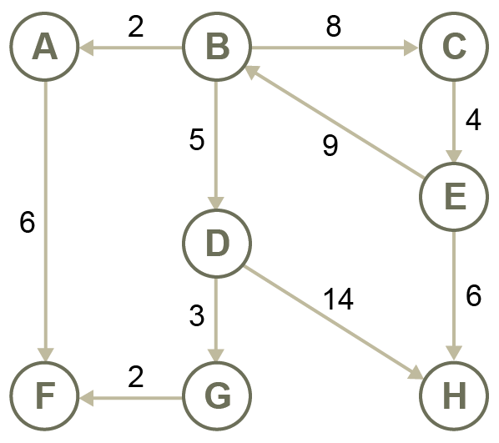

3. (a) Draw the graph represented by the following adjacency list.

E |  |  | [M]
F |  |  | [S, T]
G |  |  | [F, P]
H |  |  | [ ]
M |  |  | [H,P,S]
P |  |  | [ ]
S |  |  | [ ]
T |  |  | [M, F]

(The shape of the graph is not important; the edges and nodes are all that is relevant)

(b) Draw a new adjacency list for the equivalent undirected, unweighted graph.

E
T
G
M
F
H
S
P

4. (a) The following Python code represents a graph as a dictionary, with the key being a node and the value being a list of adjacent nodes. Draw the graph that it represents.

GRAPH = {
'A':['B','D','E'],
'B':['A','C','D'],
'C':['B','G'],
'D':['A','B','E','F'],
'E':['A','D'],
'F':['D'],
'G':['C']
}

(b) Show how a weighted graph could be represented as a dictionary of dictionaries. (Give some weights to the edges in your graph)

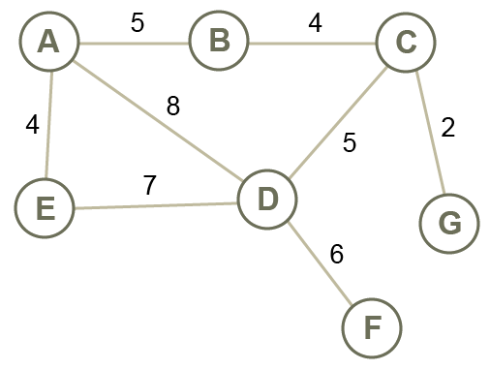

Extension task
5. Do some Internet research to find out more about the Page Rank algorithm invented by Larry Page and Sergei Brin.

